**USER PERSONA & SEGMENTATION**

## **INTRODUCTION**

One of the frequently asked questions in a PM interview are the Product Design Questions. These questions are designed to assess your ability to:

* identify a problem as it relates to a specific market or context
* and solve those problems.

The concepts we will learn this week will help us in acing the product design questions.

While designing a product, a Product Manager focuses and empathizes with a single customer segment or persona. And then he/she gives a solution that solves a specific need of the selected segment.

In this module, we will learn how to segment customers and create their persona.

### **Why is it Important in Product Management?**

* Personas are used to help a product manager understand key **traits, behaviours, goals, responsibilities and needs** of a specific type of user
* Personas are used while **developing**, **designing** and **marketing** to understand real customers’ needs
* Personas help in **developing products** with stronger appeal and use

### **What should you be able to do by the end of this?**

* Learn how to segment users
* Sketch Persona for segments
* Understand how depending upon the persona/segment product requirements change

## 

## **MARKET SEGMENTATION**

## 

A product may solve multiple problems. To different customers, the benefits can also vary which can shift the perceived value of the product. So, while designing a product, a PM should first select a single customer segment.

**Segmentation** refers to **aggregating prospective buyers** into groups with common needs. It helps in mapping the competitive position of an upcoming product by tailoring it to the customers.

The process of using marketing segmentation starts even before your products enter the market. Your offerings may start with a skill or interest of yours, such as creating clothing for plus-size women. But after you define this broad focus, the needs of your target market will, in turn, define the products and services you develop.

You may segment your primary market into subgroups, such as older and younger plus-size women, plus-size working women and athletic plus-size women. The better you understand the needs and interests of each of these groups, the better you'll be able to create products they'll specifically want to buy.

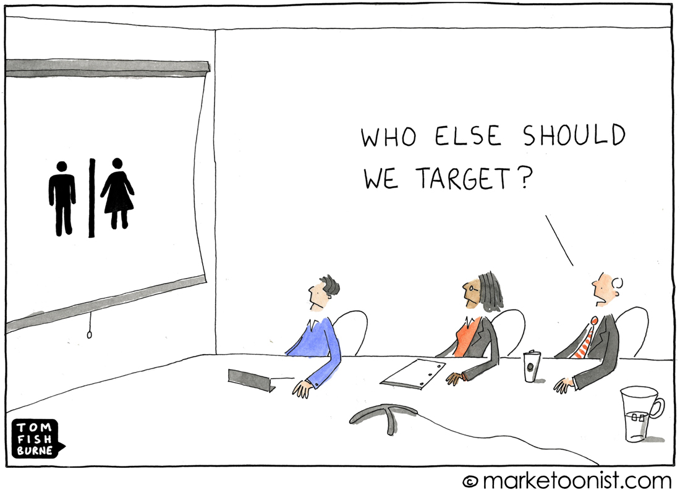

#### 

|  |
| --- |
| **WATCH**  [How to Use Market Segmentation](https://youtu.be/pCLQkgcjMjY) By Alanis Business Academy - 16 Min Watch |
| What are the 4 distinct methods by which we segment the market?   * Demographic - age, gender, income, education etc. * Geographic - regional (country, state), tier 1/2/3, rural * Psychographic - interests, lifestyle, attitude * Behavioural - ‘actual’ behaviour inferred probably from past buying habits |
| What factors come under Psychographic Segmentation?   * 1) Interests 2) Lifestyle 3) Attitude 4) Opinion |
| How is Behavioral Segmentation different from Psychographic Segmentation?   * Behaviour - What benefits do customers want and how they use our product (daily user/ monthly user/ potential user/ 1st time user)? * Psychographic - How do customers live their lives and what do they think about and value? |

|  |  |
| --- | --- |
| **ACTIVITY #1**  **What relevant segments exist in the market of the Zoom app? Identify at least 3.** | |
| * Businesses and Corporates * Academia (Schools and Colleges) and EdTech Industry * Webinars & Workshops for very large audiences | |
| **Identify how Zoom can customize its app for each of these Segments.** | |
| * //security++, easy to annotate and collaborate * //swift and easy content dissemination of various formats, save content along with recording * //joining via QR codes, works good at low connectivity | |

## Now that we have understood the fundamentals of Segmentation, let us understand what are User Personas and why are they used.

## **USER PERSONA**

Personas are used by PMs to have a **user-centred design approach** for their product. They are descriptions of a typical member of a target segment, and they are used to bring segment members to life and to better envision how a customer might think or feel.

Personas are profiles of fictional, archetypal customers that describe their personal stories/goals/motivations, based on a synthesis of findings from interviews, ethnography, and other customer research.

|  |
| --- |
| **WATCH**  [How To Create UX Personas](https://youtu.be/B23iWg0koi8) By UX Mastery - 3 Min Watch |

To understand User Persona further, let’s go through a mini-case and answer a few questions.

#### 

|  |
| --- |
| **READ**  [Segmenting the Gamers at WebTel](https://docs.google.com/document/d/1FABDC_AHA6j1OomgQuYqENZDFqJJJBo6FdB4FPZmZS8/edit?usp=sharing) MINI-CASE |
| **Exercise:**  * Identify the features of a gaming product that would be suitable for   + Escapist Gamer - easy learning curve, relatable characters, provide relaxing experience instead of being cognitively demanding   + Genre Specific Gamer - newer and more realistic versions( improved graphics) of the game are released regularly (maybe yearly) which enables him to better experience his fantasies(like FIFA, NBA etc.), multiplayer (online/offline) -must,   + Multiplayer Gamer - multiplayer game with strong storyline and hidden rewards but not very technically demanding, live-streaming, gaming tournaments with cash rewards |
| What requirements or use cases would be common among these segments?   * Escapist & multiplayer gamer - affordable, hardware and software requirements are low,  Genre specific & multiplayer gamer - multiplayer |
| What requirements or use cases would be different among these segments? |

**Key Elements of a Persona**

* Name and image
* Key demographic and behavioural information (e.g., when/where/why/how often they use the product)
* Job description, if B2B
* Key goals, needs, worries, motivations
  + Quotes can help illustrate these
* Implications of goals/needs/etc. for solution
* 3-7 personas are typical; 1-3 of these should be “primary”

Cindy Alvarez in her book Lean Customer Development suggests a few questions that we should keep in mind while creating Persona:

* Do the customers value cash or they value time?
* Are they decision acceptors or decision-makers?
* Do they want more control or more convenience?
* Are they low-tech or tech-savvy?
* Do they value adventure or they value predictability?
* Do they enjoy highs and lows? Or do they prefer consistency?
* What do they worry about the most?
* What successes or rewards do they find the most motivating?
* What social identity (teenager, mom, frequent business traveller, retiree, athlete, etc.) do they use to describe themselves?

**NOTE:** This is not an exhaustive list. Questions would vary depending on your product & industry.

|  |  |
| --- | --- |
| **ACTIVITY #2**  **Identify different segments of LinkedIn users and describe their needs.**  **Hint:** While LinkedIn is a professional networking site, think about the different needs of those who browse/explore LinkedIn. | |
| * Job seekers - I need the best job that I can get with my experience and skills. * Recruiters - We want to hire the best talent who believes in what we do and can add value to the organisation. * Professionals socialising - I want to share what I have learnt from my experience in this industry and want to connect to and learn from other people in different sectors. | |
| **Now that you have segmented LinkedIn users, determine which product features (existing and future features) would be useful for each segment.** | |
| * Job seekers: 1) Make a profile highlighting your skills (and your proficiency in those skills adjudged by your peers) and experience and reach out to people 2) Put on Job Alerts for the role you are interested 3) Finding those alumni of your college/school and those connections that work in a particular organisation and ask for their referral * Recruiters - 1) Machine Learning based profile recommendations for your vacant roles 2) Get updates if a prospective candidate updates their profile with a new skill, education or experience 3) Send targeted messages to professionals following your organisation’s linkedin page to reach out to potential applicants for a role * Professionals socialising - 1) Look for people who studied in a specific university/working in a specific company and instantly connect with them 2) Join discussion groups of your interests 3) Share anything as a post and discuss with your connections on their views on the topic | |

|  |  |
| --- | --- |
| **ACTIVITY #3 CREATE USER PERSONA**  **Identify the different segments of users served by GooglePay and articulate their needs.**  **Hint:** Some customers want better usability and quick service. Others would compromise on usability for added security features. Think about the problems that different users face while using the app. | |
|  | |
| **Decide what product features you will build for each of these segments.** | |
|  | |

|  |
| --- |
| **FORM**  [Review & Doubt Collection](https://docs.google.com/forms/d/e/1FAIpQLSe0S8zzQy9wUGns3bi6_Kog07gbMWDX2hu5fDtnjIIim034-w/viewform?usp=sf_link)  By Team Upraised - 2 Mins |